Chapter 1, Solution 15

(a) 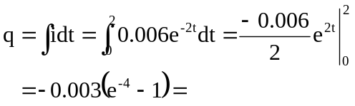
2.945 mC

(b) 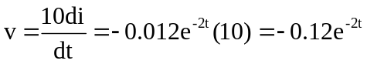 V this leads to p(t) = v(t)i(t) =
(-0.12e^{-2t})(0.006e^{-2t}) = –720e^{–4t} µW

(c) 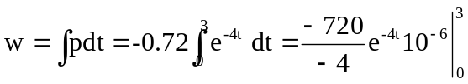= –180 µJ

